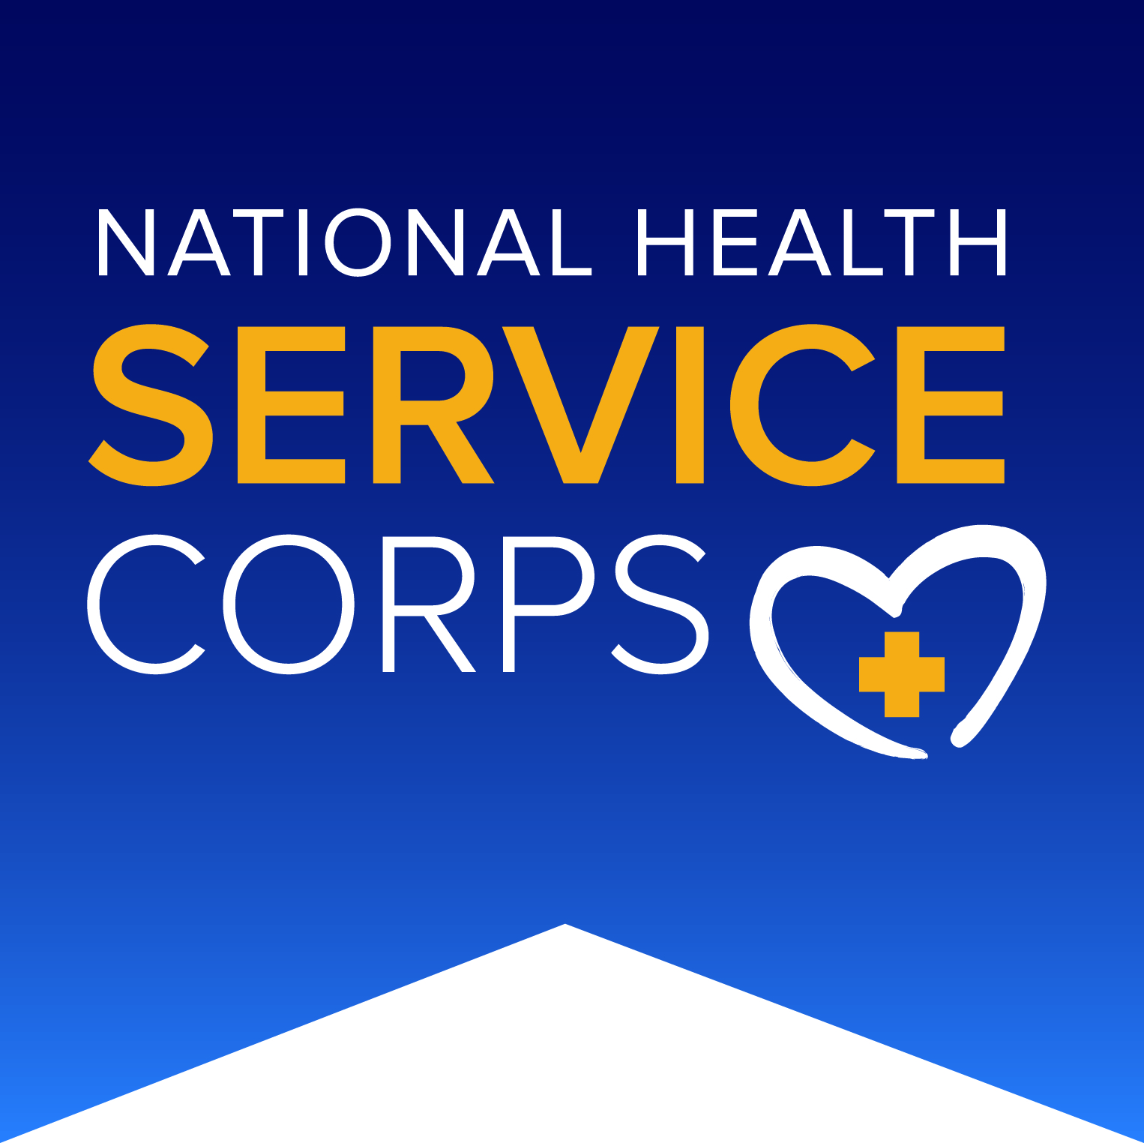

National Advisory Council on

The National Health Service Corps (NACNHSC)

April 2 – 3, 2019
Health Resources and Services Administration
5600 Fishers Lane, Conference Rm 12SWH01, Rockville, MD
Call-In Number: 888-455-0640; Passcode: HRSA COUNCIL
Adobe Connect: https://hrsa.connectsolutions.com/nacnhsc

Meeting Agenda

Tuesday, April 2, 2019

9:00 am – 9:15 am Welcome and Introductions
Adrian Billings, M.D., PhD, FAAFP
Chair, National Advisory Council on the NHSC

9:15 am – 9:30 am Opening Remarks and Accept Minutes from September 2018 Meeting
Adrian Billings, M.D., PhD, FAAFP
Chair, National Advisory Council on the NHSC

9:30 am – 9:45 am NHSC Update
Israil Ali, MPA
Director, Division of National Health Service Corps
Bureau of Health Workforce

9:45 am – 10:00 am BREAK

10:00 am – 10:30 am Bureau of Health Workforce Updates
Torey Mack, MD
Deputy Associate Administrator
Bureau of Health Workforce

10:30 am – 10:45 am BREAK

10:45 am – 11:15 am BHW NHSC Clinician Tracker
Michael Dembik
Bureau of Health Workforce

11:15 am – 12:30 pm Review Council Priorities
Adrian Billings, M.D., PhD, FAAFP
Chair, National Advisory Council on the NHSC

12:30 pm – 1:30 pm LUNCH

1:30 pm – 3:30 pm Discuss Council Recommendations and Draft Outline

3:30 pm – 3:45 pm BREAK

3:45 pm – 4:00 pm Timeline for Letter of Recommendation

4:00 pm – 4:15 pm Public Comment

4:15 pm – 4:30 pm Recap of Day 1 and Plan for Day 2

4:30 pm Adjourn

Wednesday, April 3, 2019

8:30 am – 8:45 am Charge of the Day
Adrian Billings, M.D., PhD, FAAFP
Chair, National Advisory Council on the NHSC

8:45 am – 9:00 am Council Business
Adrian Billings, M.D., PhD, FAAFP
Chair, National Advisory Council on the NHSC

9:00 am – 10:00 am Prioritize Council Recommendations - Small Group Reports

10:00 am – 10:15 am BREAK

10:15 am – 12:00 pm Group Discussion on Proposed Recommendations

12:00 pm – 1:00 pm LUNCH

1:00 pm – 2:00 pm Next Steps: Process to Formalize Recommendations
Adrian Billings, M.D., PhD, FAAFP
Chair, National Advisory Council on the NHSC

2:00 pm – 2:15 pm Public Comment

2:15 pm – 2:30 pm Closing Remarks & Next Steps
Adrian Billings, M.D., PhD, FAAFP
Chair, National Advisory Council on the NHSC

2:30 pm Adjourn

